Creating a react-app
Open terminal - type “npx create-react-app nipeksha-app”
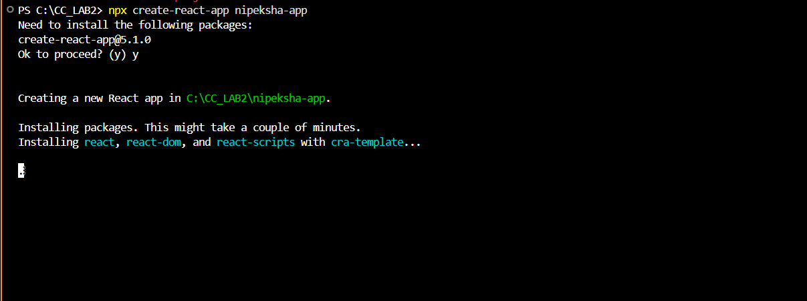
Create a “components” folder and add “welcome.js” file.

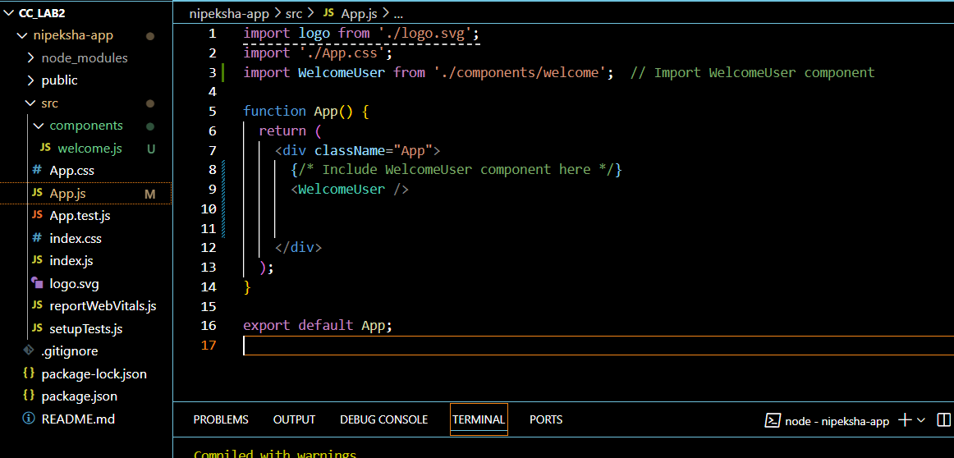

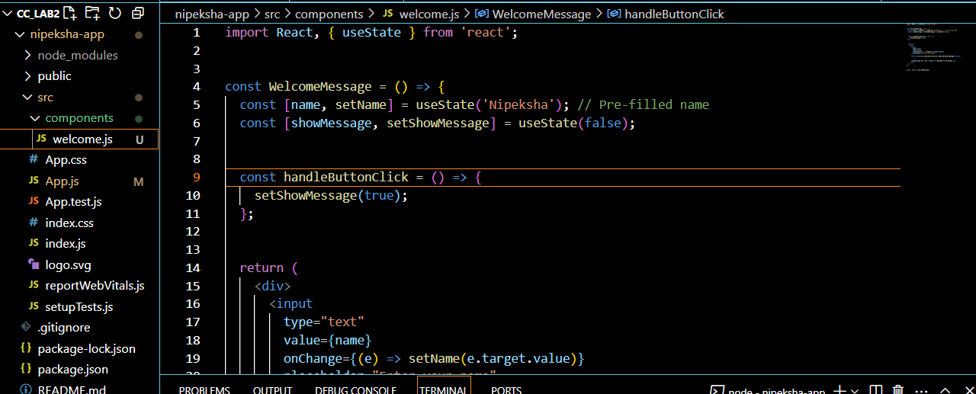

In terminal , type -” npm start “


Login to AWS Academy -> search bar -> S3 -> services

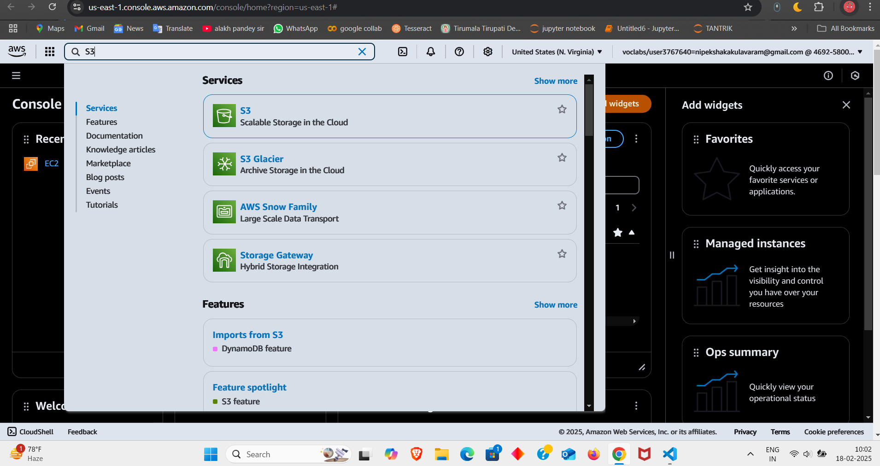
Click on “Create bucket”
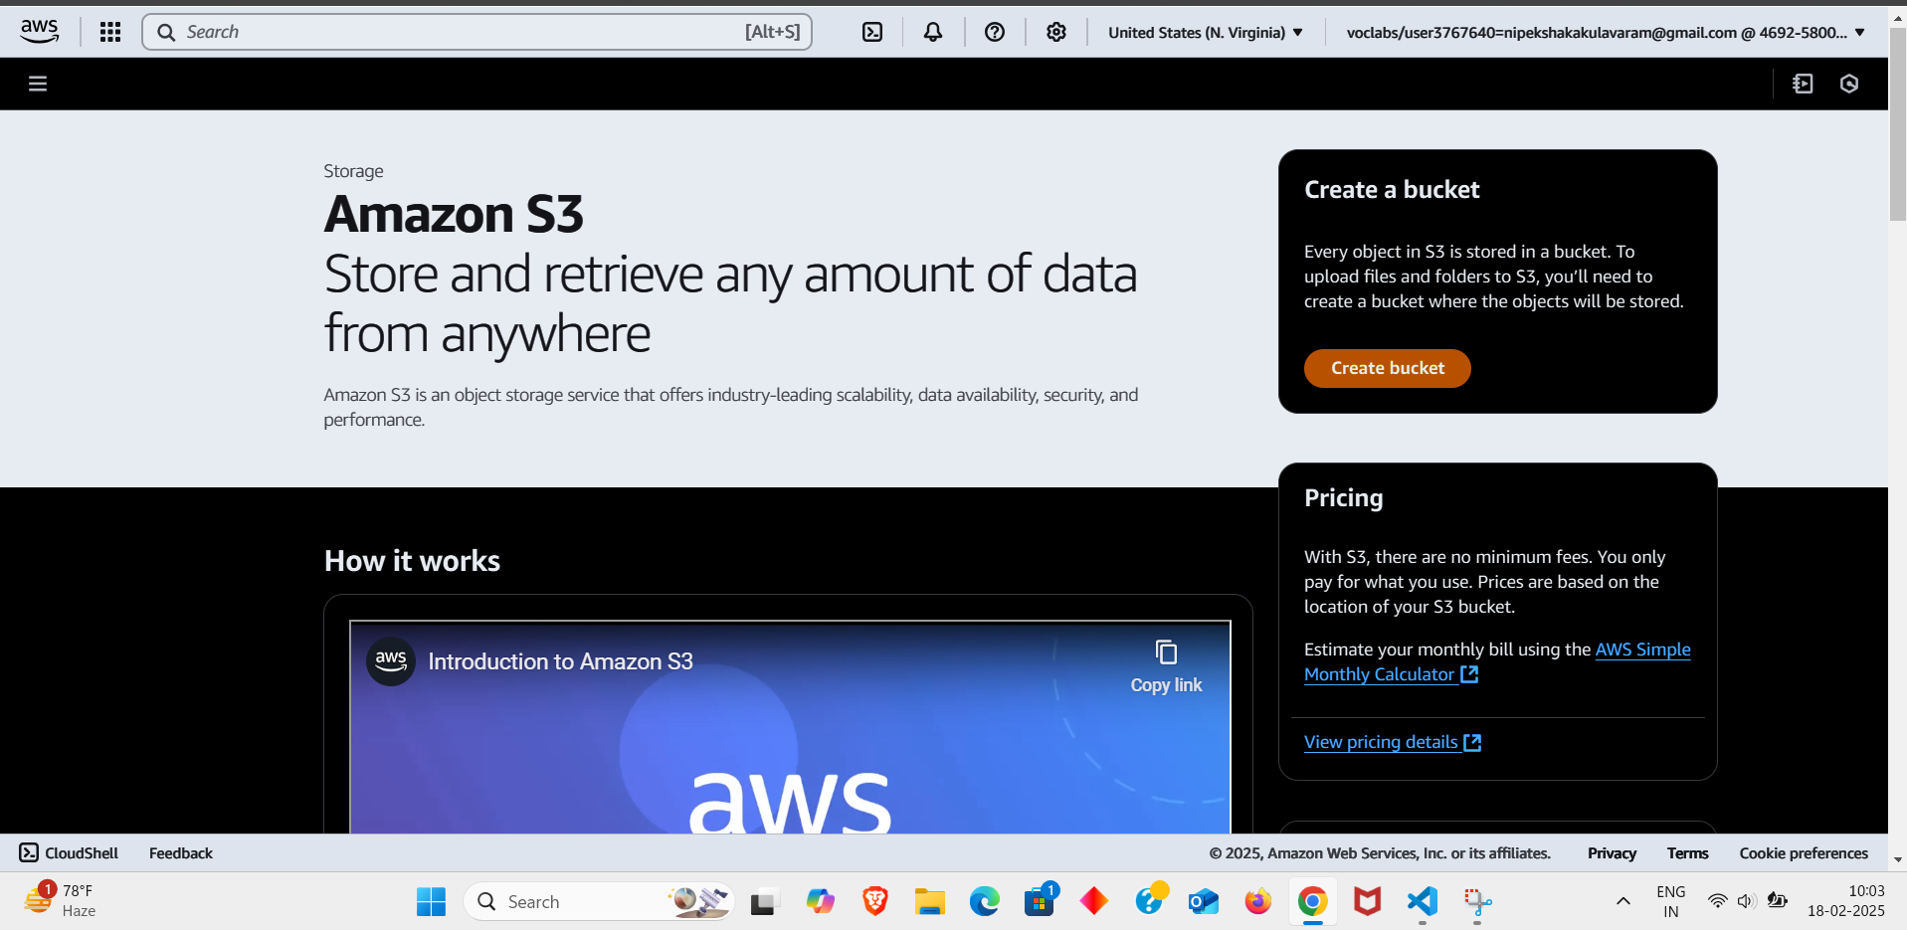

Enter bucket-name as “22bd1a057a-s3”
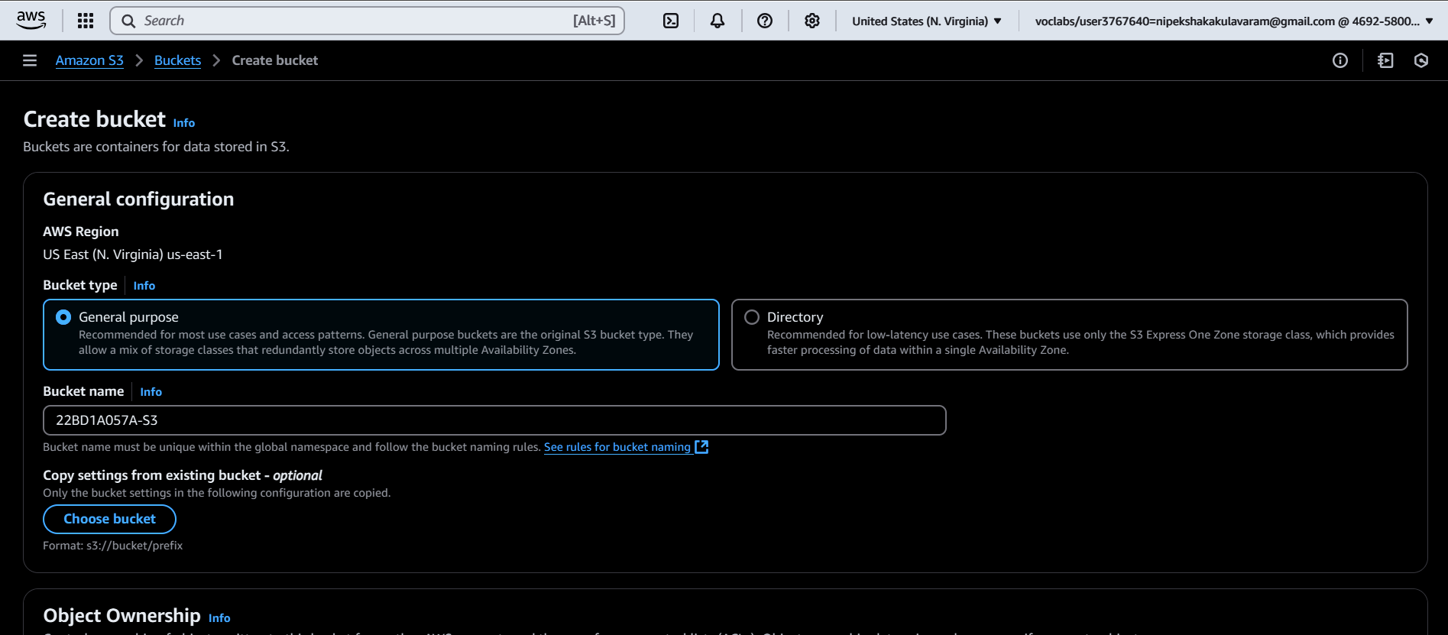
Bucket has been successfully created

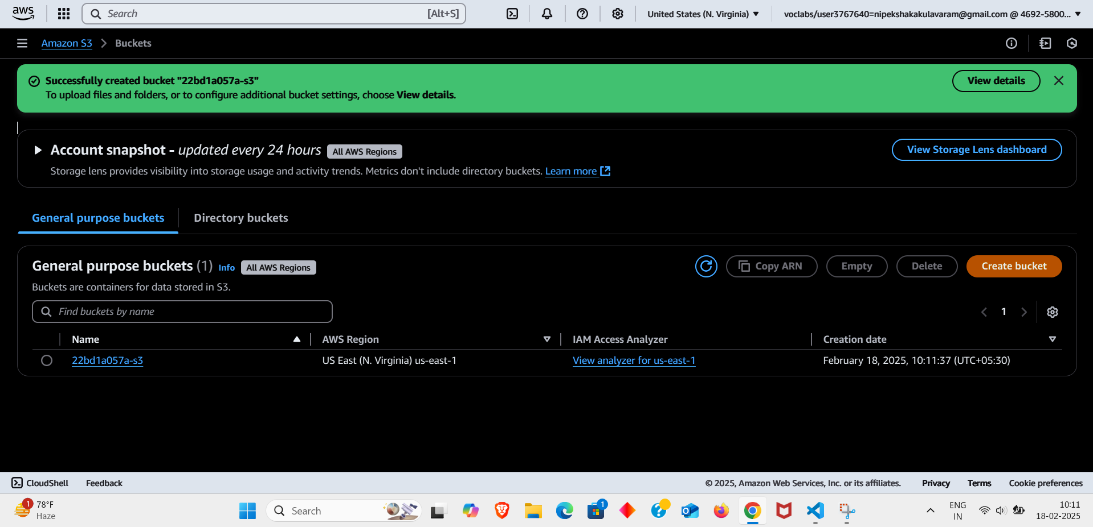
Go to Objects -> upload -> upload only build file

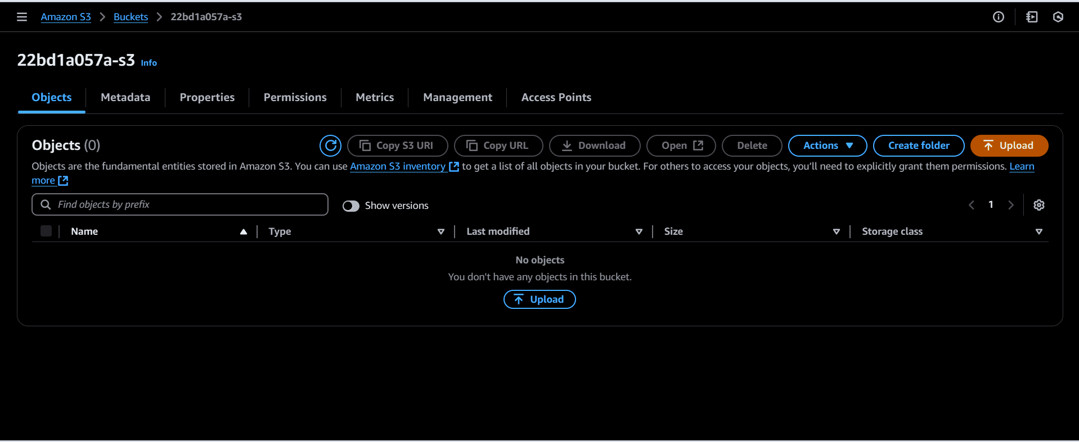

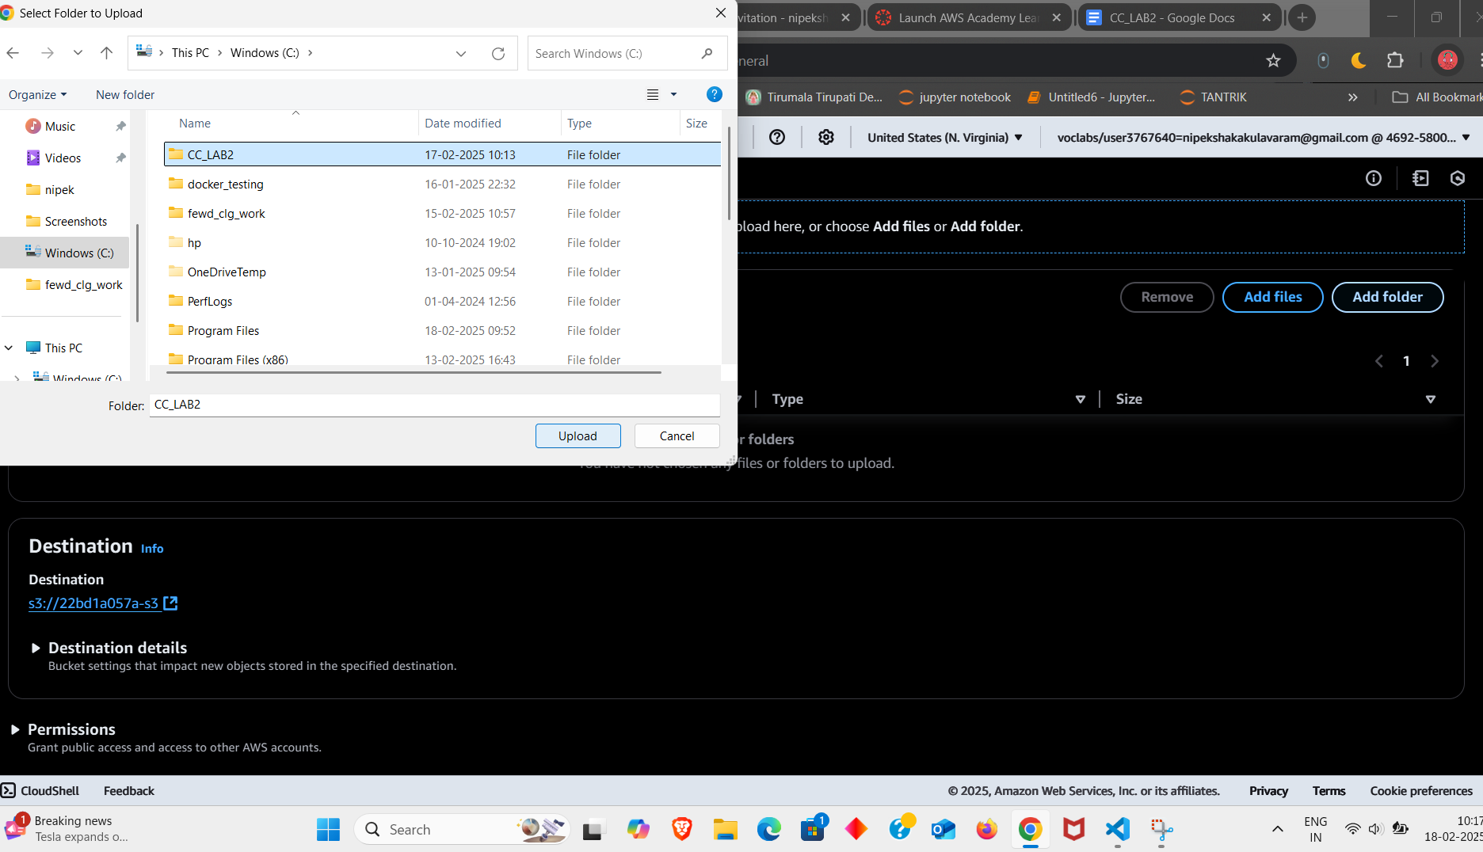

Scroll down and “Enable” Static website hosting -> type “index.html in Index document -> save changes
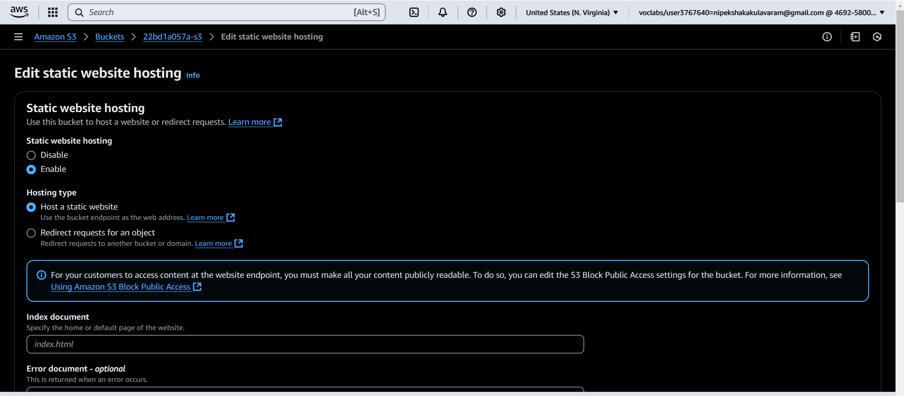

“Static website hosting” has been successfully edited. Now click on “Properties”
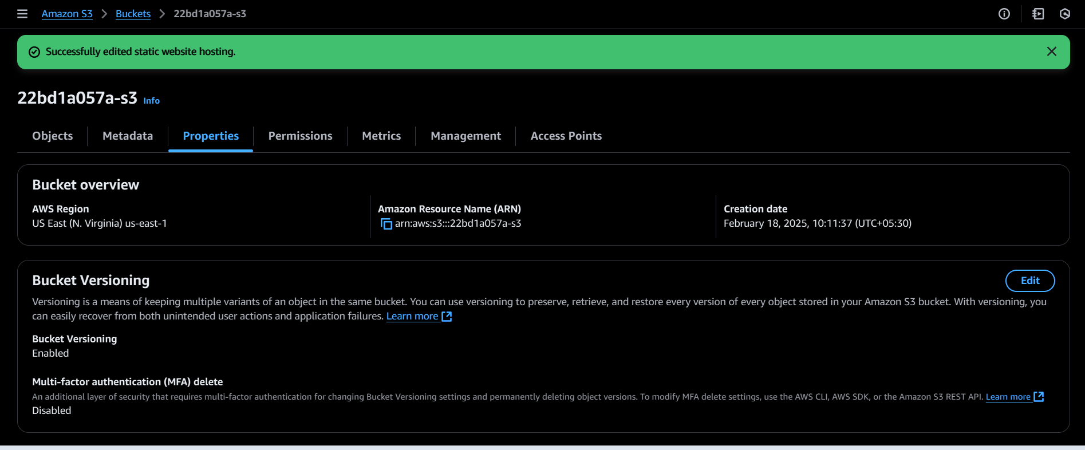

Edit bucket versioning -> unblock all public access -> save changes
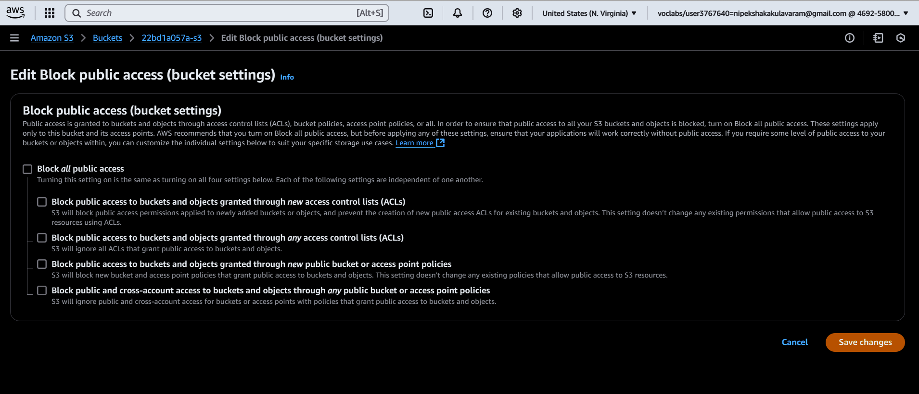

Go to “permissions”

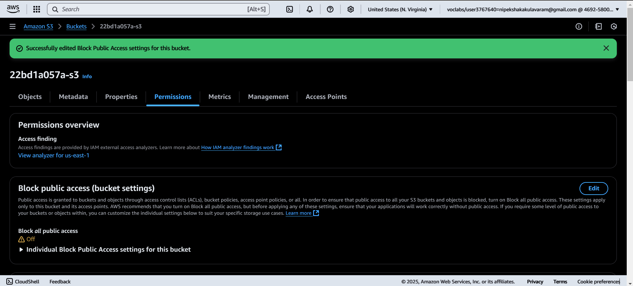

Scroll down to Edit bucker policy -> policy generator
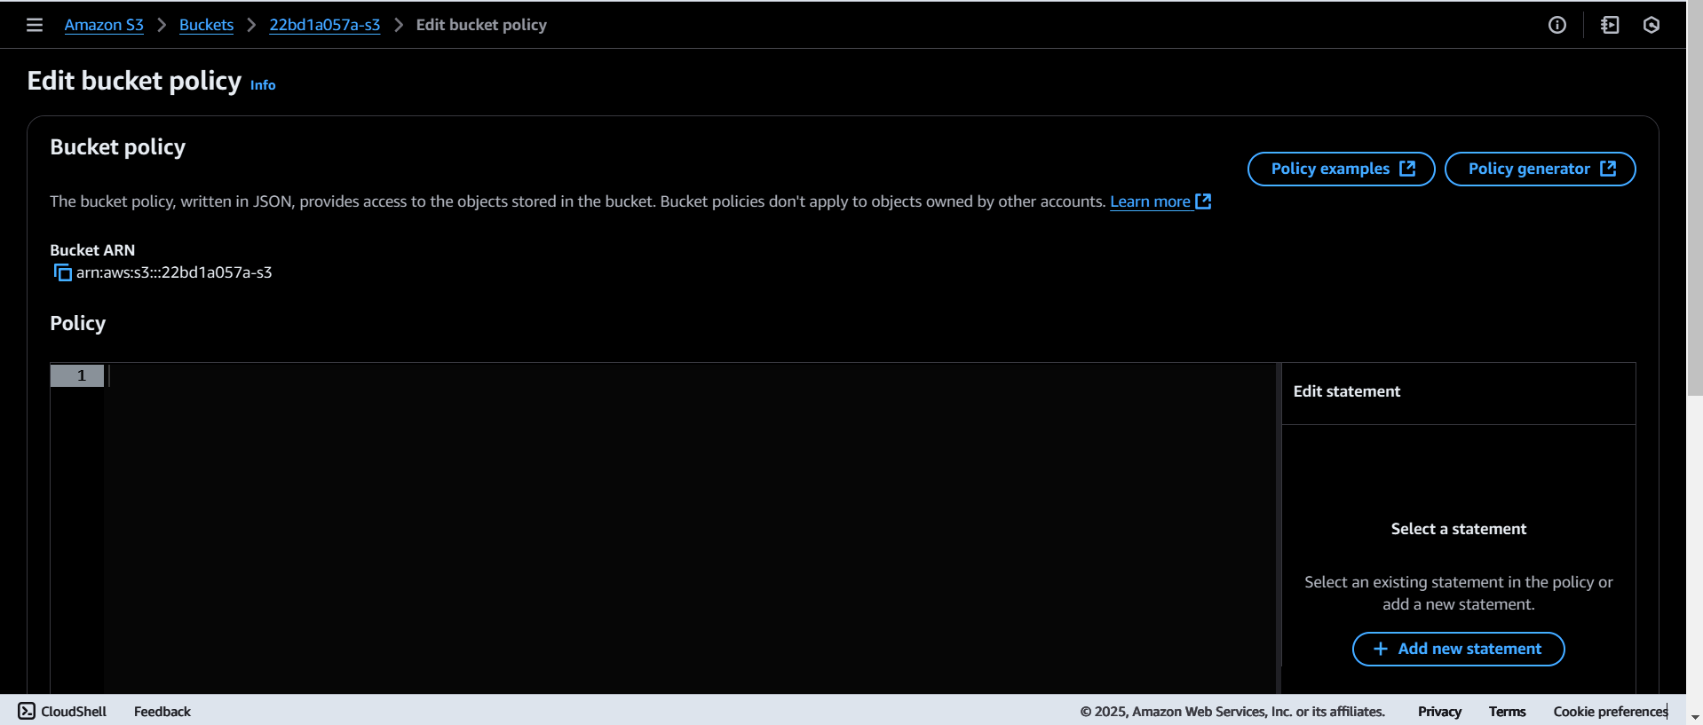

In Policy generator -> select type of policy (SQS Queue Policy) , in select actions ->(getObject) and then copy paste amazon resource name from Bucker ARN
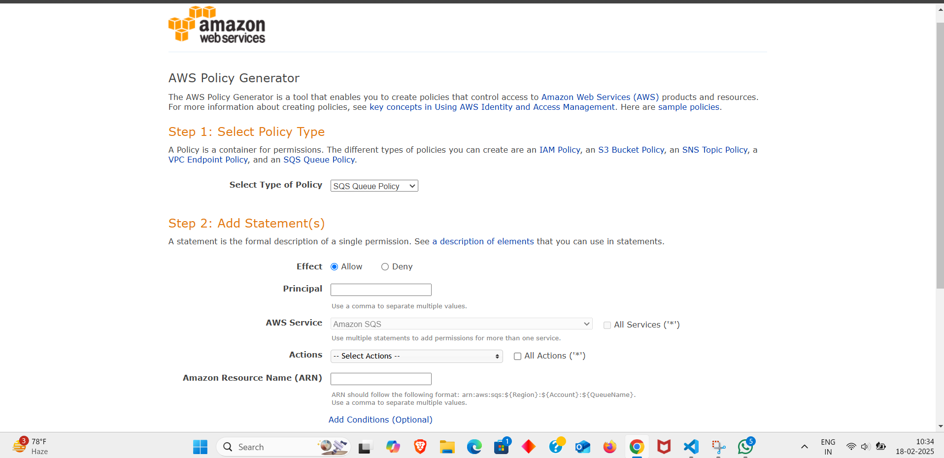
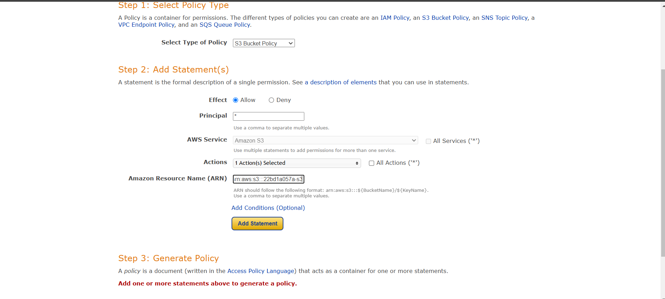

Click “Add Statement” -> Policy JSON document -> copy the code
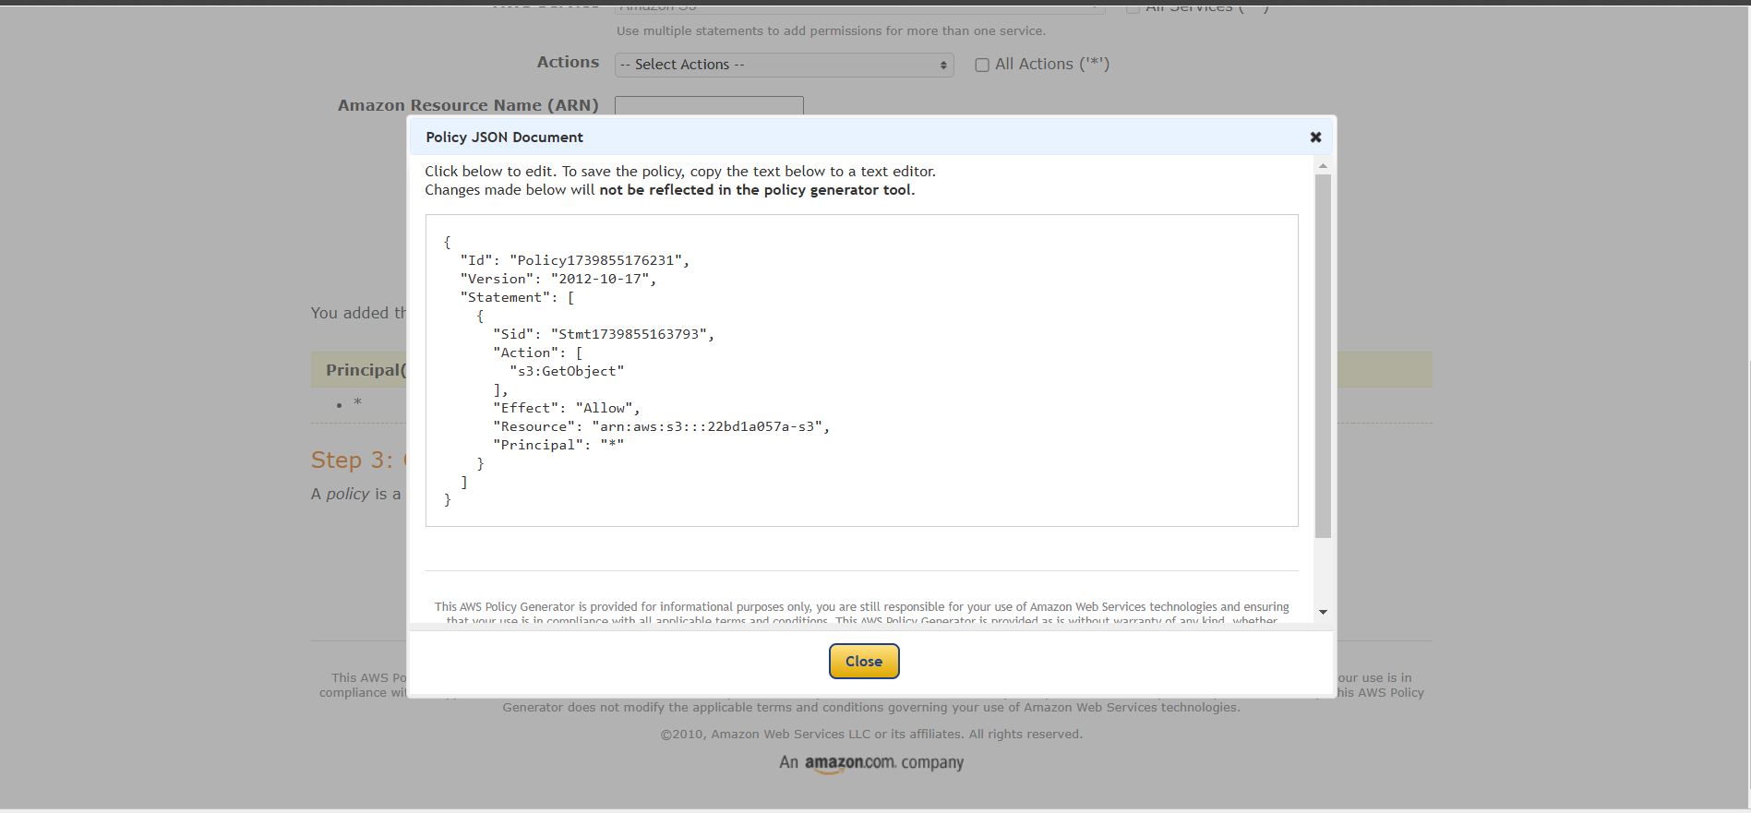

Paste it in “Edit bucket policy” and add “/*” in the last of “Resource”
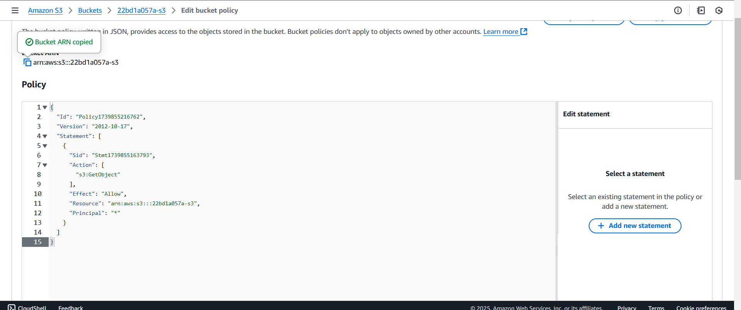
Click “save changes”

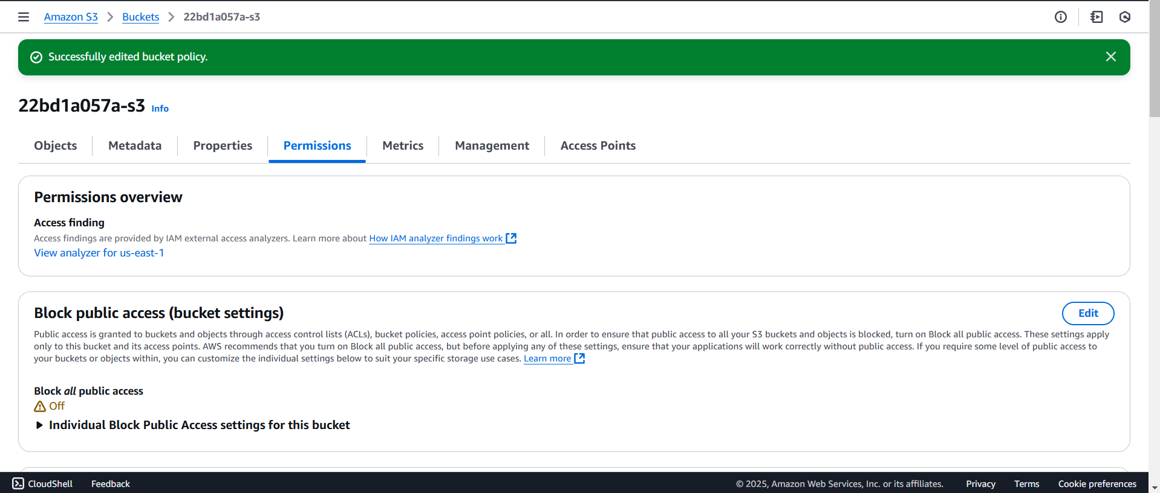
Objects -> upload only build folders (copy paste the files in build folder one after the other)

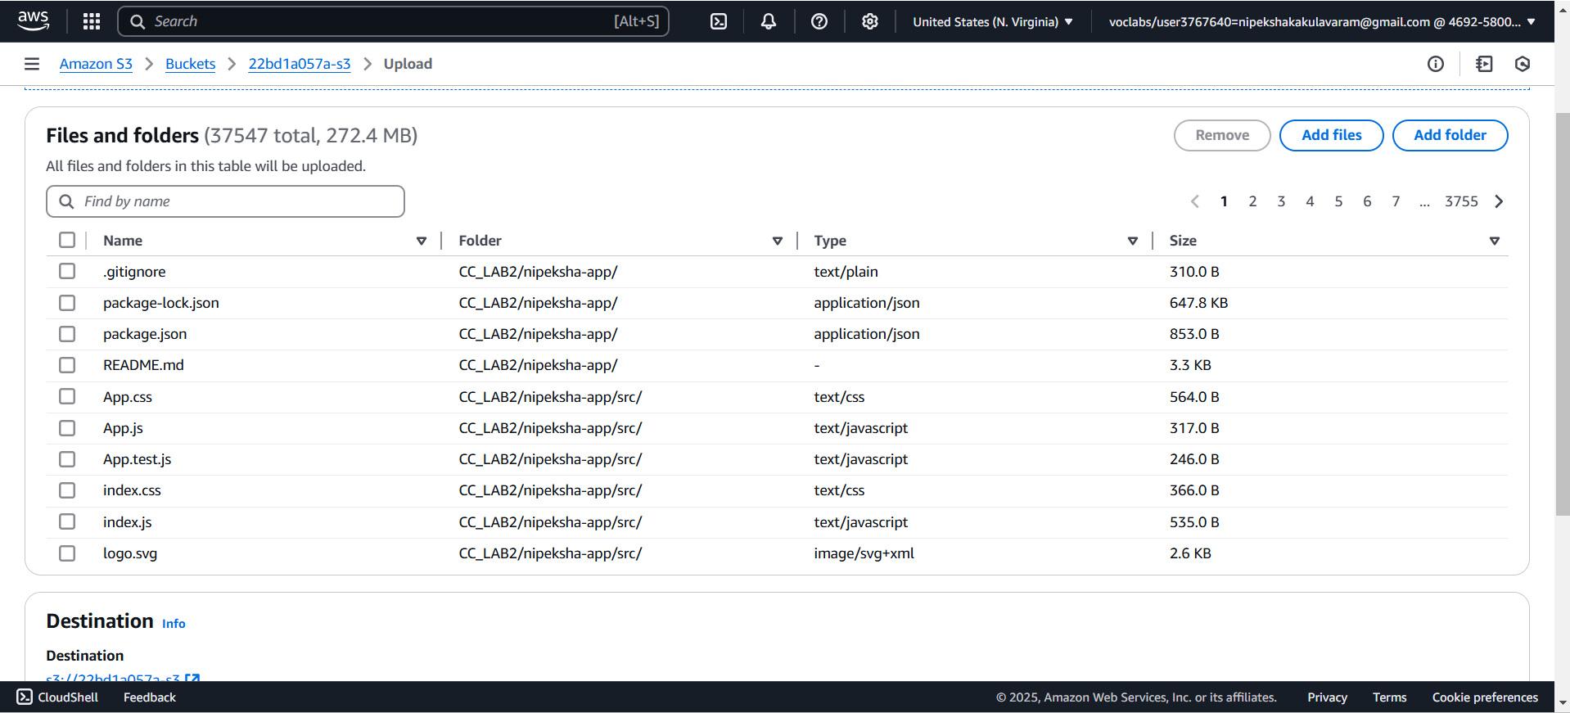
Click upload

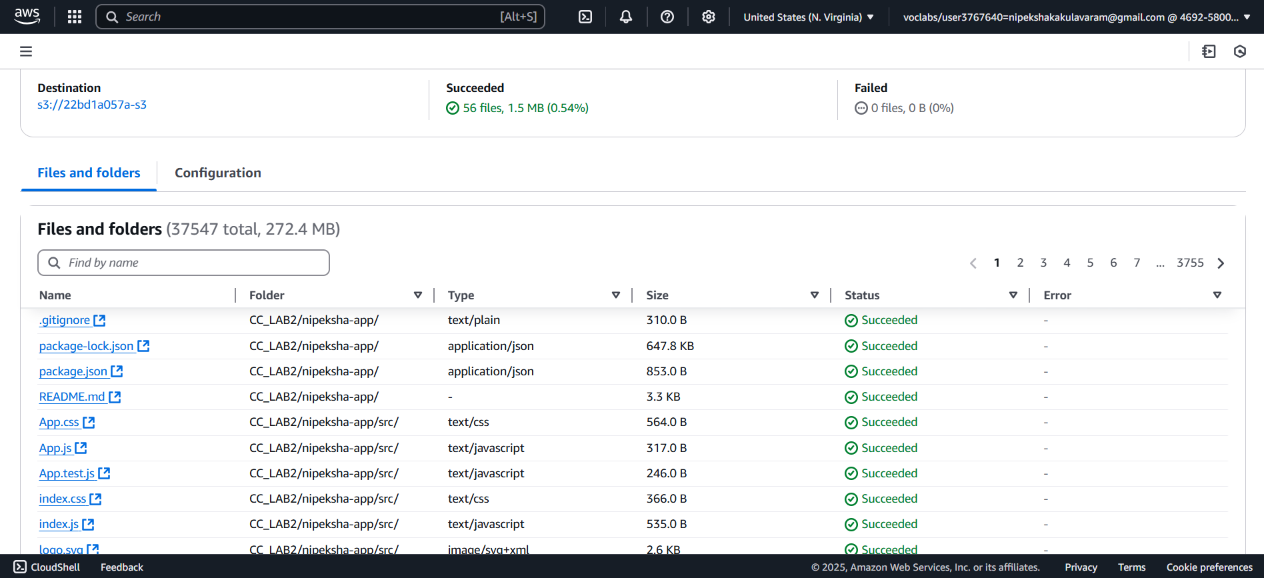
Go to “properties” scroll down, “open bucket website”

